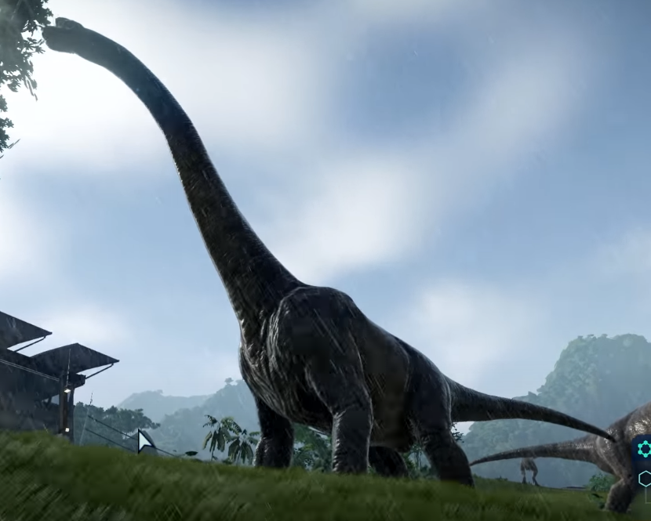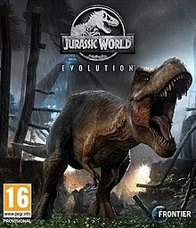

I saw this dinosaur in the 2018 video game Jurassic World Evolution. I believe this is a Brachiosaurus. I found the scale, its long neck, that it walked on 4 feet and ate from tall trees to be very accurate. The pigment and the look of their skin could be inaccurate to the actual dinosaur. Thoroughly breathtaking, I enjoy park building games so mixing that with accurate looking dinosaurs and watching them move and interact was amazing.

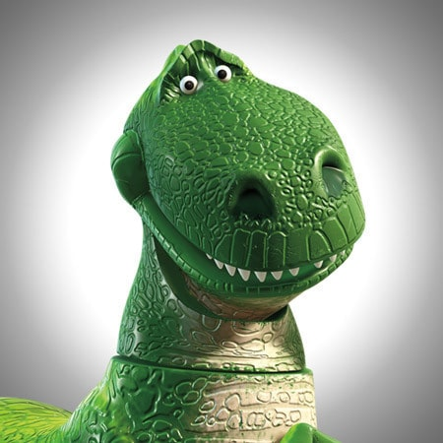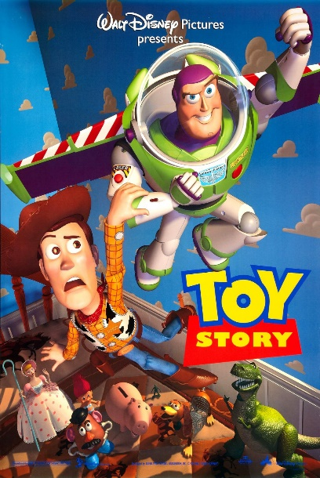

I saw this in a Movie. This Is Tyrannosaurus Rex as seen in the hit 1995 Disney movie, about toys coming to life when people weren’t looking. The basic body autonomy of the T-rex, that being that big head, small hands, bi pedal movement were accurate. What I found inaccurate was the very saturated green color, very inaccurate scale it was way too small, toy like joints, made of plastic, cute face. I think it’s perfect, It’s a very adorable and a great T-rex as a toy.

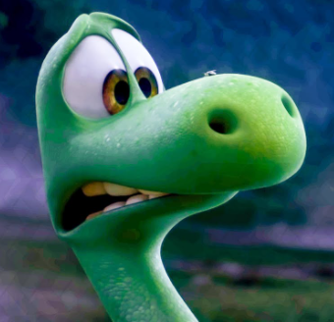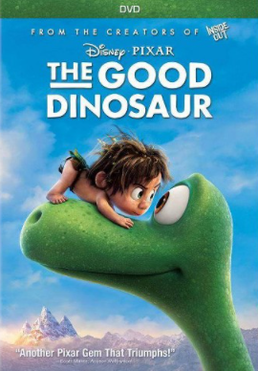 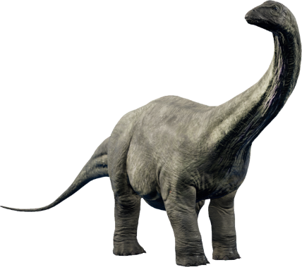

I saw this in a Movie. This is Arlo from the flop dinosaur movie The Good Dinosaur. From what I found Arlo is an Apatosaurus. Like T-rex from the Toy Story, Arlo has been Disneyfied. He has the basic shape of a quadrupedal herbivore with a long neck, like Apatosaurus or Brachiosaurus. There is a lot that is inaccurate or realistic with this, the hulkish almost alien green color, also the body proportions, the cute face. While I enjoy the cute dinosaur look, I would have preferred it if they made him more accurate.

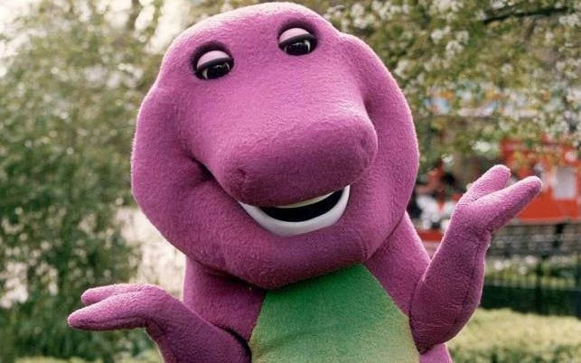

I saw this on the TV. This is Barney from the famous now discontinued show Barney and friends. He is a Tyrannosaurus Rex. There isn’t much accurate when it comes to Barney. He is a bipedal, has a large head, small arms but on the other hand he is purple with a green belly has eyelashes and the smoothest teeth ever. this is very nostalgic, and I think its fine for what it was. Being a kids show I don’t think it would have helped to have a very realistic suit.

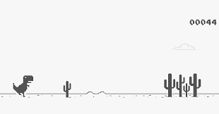

I saw this when I lost internet connection. From what I found the game is also called T-Rex Runner, so I think its safe to assume that the dinosaur in this is a Tyrannosaurus Rex. It is a bipedal, it has a large head, and small hands. It seems to be pixelated, 2d and only has one arm and running endlessly in a dessert jumping over cactuses. While the detail is lacking in the portrayal of the Tyrannosaurus, I think its easy to recognize that it’s a dinosaur.